Instructions

1) Position yourself at eye level with the barbell. Open your legs at a 45 degree angle.

2) Most of your back must **touch** the seat during bench press. A big arch like this, although it is being used at powerlifting , is for a shorter range of motion that doesn’t have the highest chest muscles activation. 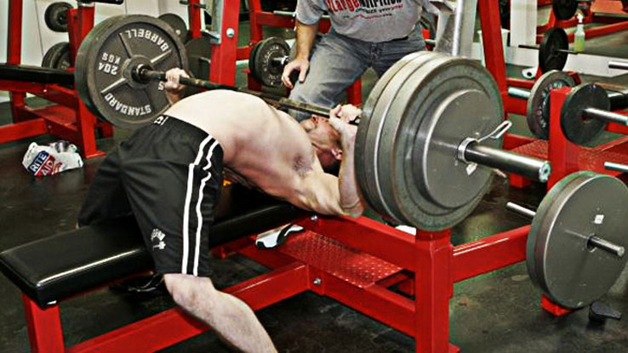

3) Grasp the barbell with a wider than shoulder-width grip, wrapping thumbs around the bar. Hold the barbell at arm's length above your upper-chest area.(1*)

4) A spotter will help you with unloading the weight.

1. During the eccentric phase inhale.

2. The isometric position is the hardest one requiring your maximal effort.

3. During the concentric phase you will have to exhale and try to push as much as you can.

4. You succeed in the lift once you reach the point that you started from in fully flexed arms.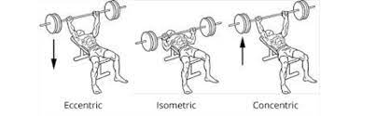

5) In case you can’t move from the isometric position the spotters will intervene. Avoiding injury is our priority. Thanks for your cooperation!

WARM UP

Since the athletes are not elite we will follow a similar but not identical warm up to one provided for top powerlifting athletes trying to PR every athlete will do 10 reps with an empty bar , 10 reps with 30% of his 1RM, 5 reps at 60% , 1 reps at 80%, 1 rep at 90%, 1 rep at 100% and from there the experiment will begin adding 5% percent to the previous 1RM.

Each person is expected to need close to 30 minutes to complete the training regime.

Thank you,

Dimitrios, Reinaldo, Ming, Marco, Kevin!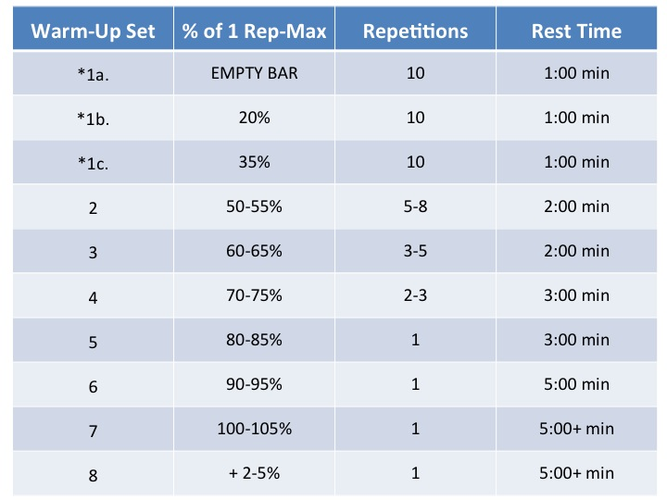

1* <https://us.humankinetics.com/blogs/excerpt/a-step-by-step-guide-for-a-proper-bench-press> **This is an excerpt from** [**Youth Strength Training**](https://us.humankinetics.com/products/youth-strength-training) **by Avery Faigenbaum & Wayne Westcott.**

Before lifting the barbell, the shoulder blades shrink back and then sink, open the hands, draw the lower arms inward first, and then lean the upper arms against the body, the distance between the hands is the distance of holding the barbell.

Your body position should be at eye level with the barbell and don’t lean too backward when you lift the barbell. No back lift is allowed at this bench press performance that might enforce different results.

The Valsalva maneuver is performed by a forceful attempt of exhalation against a closed airway, usually done by closing one's mouth and pinching one's nose shut while expelling air out as if blowing up a balloon.

Before lifting the pole, the shoulder blades shrink back and then sink, open the hands, draw the lower arms inward first, and then lean the upper arms against the body, the distance between the hands is the distance of holding the pole

Do not breathe a lot of air when doing bench-press. In the concentric phase inhale and during the eccentric phase exhale when you start lifting the barbell.

In the preparation time, first hold the barbell and then twist your wrist to outside, it can make the chest muscle contrast. But do not use too much force on twisting. Just a bit of rotation force.